

V 1.2
June 2026
XStep Design Specification
SMPL: Top-Off Tank Details

Table of Contents
1 Purpose 3
2 Overview 3
3 Reasons for developing 5
4 Authorization 5
5 Assumptions/ Dependencies 5
6 Validation Checks 5
7 XStep Layout Design 6
8 Function Module(s) 6
9 Pseudocode 13
10 Configuration Specification 18
11 Test Scenarios 18
12 Revision History 21

Purpose
This document outlines the design, along with the configuration specifications for the XStep “SMPL: Top-Off Tank Details”.

Overview
The SMPL: Top-Off Tank Details XStep facilitates the entry of top-off solution details when applicable during buffer preparation. The operator is prompted to indicate whether a top-off is required.
The XStep contains two main input parameters:
- IV_HEADER - This can be changed in SiMPL MBR to display specific header text for the XStep
- IV_INSTR - This can be changed in SiMPL MBR to display a specific set of instructions for the XStep that will be displayed below the header
- IV_OB_TY_T – This can be authored in SiMPL MBR to indicate which type of equipment should be usable during the execution of this XStep. Currently, this parameter value is defaulted to “2000”, for tanks.
- IV_SIGN – This can be changed in SiMPL MBR to author standalone signatures as part of the xstep.
The XStep is an optional XStep, thus the following rules apply:
- If “Yes” is selected, all the fields in the xstep become active.
- If “No” is selected, all the fields in the xstep become inactive, not allowing any data capturing.
This information ensures accurate tracking and integration of top-off solution data into the overall batch record.
The operator executes the “Select Top Off Tank” button:
- Select Top Off Tank - Function Button
The button is linked to the function module ZSMPL_FM_GET_ASSIGNED_EQUI_EBR. This module validates the equipment ID against Equipment Master data and performs the following operations:
- “Top Off Tank ID” - Input
- “Top Off Tank Description” - Output
The operator enters the PO Number for the Primary and Previous Solutions which will auto-populate the Part Number and Batch Number fields.
- “PO Number” - Input
- “Part Number” - Output
- “Batch Number” - Output
- “Primary Solution Expiry Date” - Output
The function module ZSMPL_FM_GET_PO_PRODUCT_INFO retrieves the part numbers and the batch numbers for the relevant solutions, as well as the primary solution’s expiry date. Additionally, the function module validates that the entered PO number’s part number matches the current PO’s part number, and that the entered PO’s batch has not yet expired.
The Planned Quantity (kg) auto-populates with the Order Quantity amount of the PO.
- “Planned Quantity (kg)” - Output

Next the operator inputs values for the current tank weight:
- “Current Tank Weight (kg)” - Input

A calculation function triggers to determine the Top-Off Batch Size (kg), using the formula: Planned Quantity - Current Tank Weight (LV_PLD_QTY - LV_TANK_WT). The Current Tank Weight will be consumed against the order for the entered quantity via the process message Z_PICONS.
The result of this calculation populates into the following field:
- “Top-Off Batch Size (kg)” - Output
The new Top-Off Batch Size is passed to component weigh-out steps to re-calculate the required quantities. The steps affected are SMPL: Material Weighing and SMPL: Initial Water Addition.
Functional Design
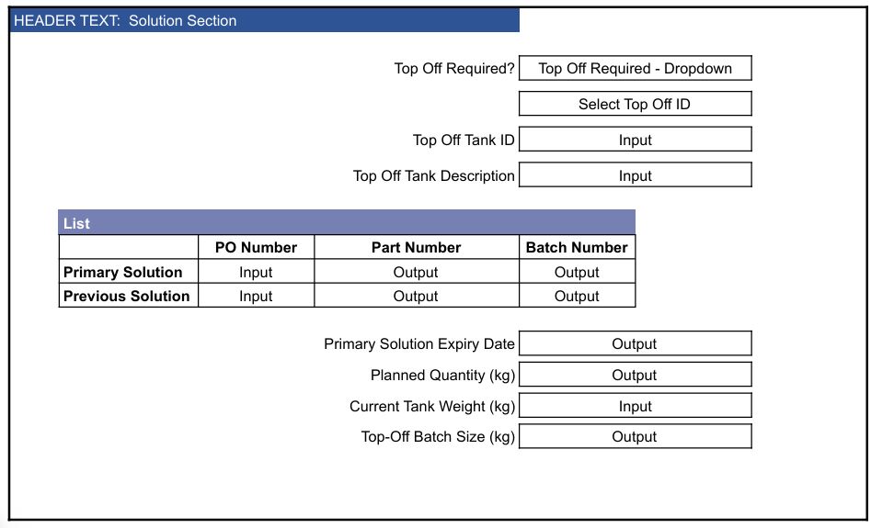

Reasons for developing
This XStep is being developed to ensure consistent, accurate, and traceable documentation of top-off solution details during buffer preparation. The step guides the operator through a structured decision and data entry process, ensuring that required information - such as tank identifiers, batch numbers, and quantities - is captured only when relevant.
Automating the retrieval of the batch number via a function module minimizes manual errors and improves data integrity. Additionally, calculating the batch size based on planned and actual tank weight ensures precision in batch tracking.

Authorization
N/A

Assumptions/ Dependencies
 | Assumption
1 | Operator signing signature fields is an approved operator in the system with the correct access configuration
2 | The function modules are available and return the required details.
3 | The function module can successfully pull the data into the output fields
4 | The calculation is based on the unit of measure being the same for the input fields

Validation Checks
Error Handling
Error | Action
Operator Signature rejected due to an incorrect username or password | Operator accepts error message and re-enter the correct username and password
Primary Solution Part Number mismatches current PO part number | Deviation occurs to indicate that products do not match
Primary Solution Batch number has expired | Operators accepts error message and signs with username & password to confirm that Primary Solution PO batch has expired
Top-Off Batch Size (kg) calculation is incorrect | Check that the batch size calculation is not negative

XStep Layout Design
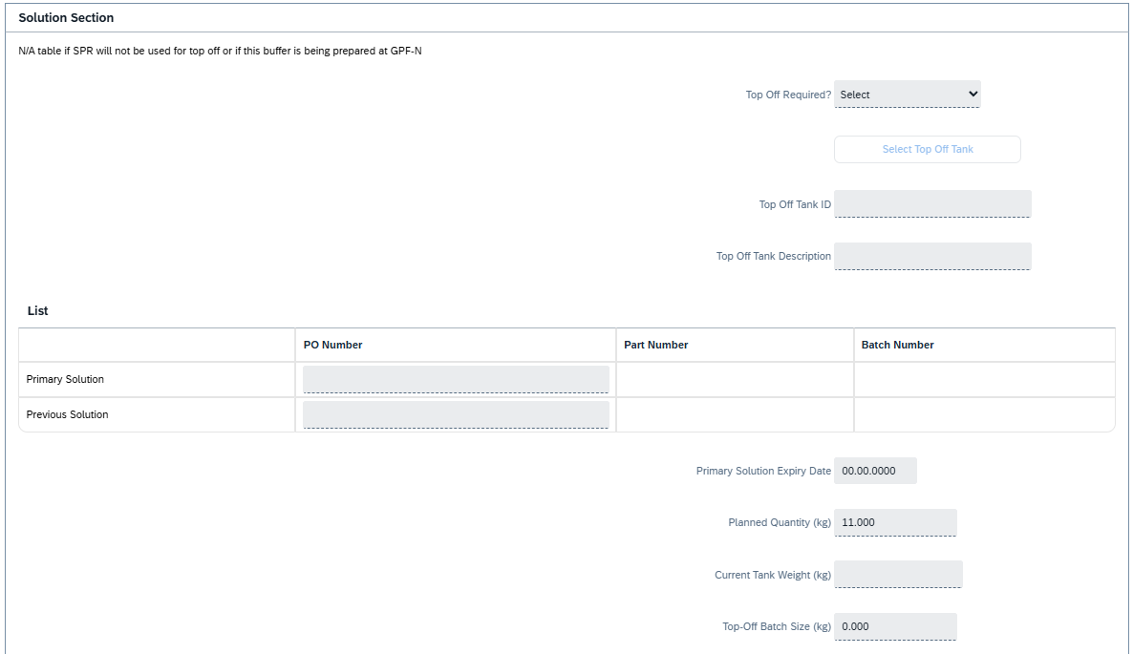

Function Module(s)
Function: /SMPL/PPPI_FM_INITIAL_ACTIVE
Import Parameters:
Parameter Name | Associated Type | Short Text
IV_ACTIVE | CHAR1 | N/A

Export Parameters:
Parameter Name | Associated Type | Short Text
EV_ACTIVE | CHAR1 | N/A

Function: /SMPL/MBR_DEP_CHECK_ACTIVE
Import Parameters:
Parameter Name | Associated Type | Short Text
IM_CONTROL_RECIPE | POC_DOCID | N/A
IM_PHASE | VORNR
IM_AUFNR | AUFNR
IM_STEP_UUID | /SMPL/MBR_SOG_UUID
IM_PLANT | WERKS_D

Export Parameters:
Parameter Name | Associated Type | Short Text
EV_ACTIVE | CHAR1 | N/A

Exceptions:
Exception | Short Text
CONTROL_RECIPE_INITIAL

Function: /SMPL/PPPI_FM_GI_SETUP_LINE
Import Parameters:
Parameter Name | Associated Type | Short Text
IV_WERKS | WERKS_D | Plant (optional)
IV_MAT | MATNR | Material (optional)
IV_DESC | MAKTX | Material Description (optional)
IV_LGORT | LGORT_D | Storage Location (optional)
IV_UOM | ERFME | Unit of Measure (optional)
IV_XCHPF | BOOLE_D | Batch managed flag (optional)
IV_INDEX | CHAR30 | Row index (optional)
IT_INDEX | /SMPL/STR_TT_SHORT_TEXT | Row index table (optional)
IV_ORDER | AUFNR | Order Number (optional)
IV_PHASE | VORNR | Operation/Activity Number (optional)
IV_QTY | ERFMG | Quantity (optional)
IV_DATE | DATS | Date (optional)
IV_TIME | TIMS | Time (optional)
IV_BATCH | CHARG_D | Batch (optional)
Export Parameters:
Parameter Name | Associated Type | Short Text
EV_MAT | MATNR | Material
EV_MAT_D | MATNR | Material (default)
EV_BAT | CHAR30 | Batch
EV_BAT_D | CHAR30 | Batch (default)
EV_BAT_V | CHARG_D | Batch (value)
EV_DESC | CHAR30 | Description
EV_LGORT | LGORT_D | Storage Location
EV_LGORT_D | LGORT_D | Storage Location (default)
EV_UOM | ERFME | Unit of Measure
EV_UOM_D | ERFME | Unit of Measure (default)
EV_ORDER | AUFNR | Order Number
EV_PHASE | VORNR | Phase
EV_QTY | ERFMG | Quantity
EV_QTY_D | ERFMG | Quantity (default)
EV_WERKS | WERKS_D | Plant
EV_DATE | DATS | Date
EV_TIME | TIMS | Time

Function: CMX_TOOLS_FM_SET_VALUE
Import Parameters:
Parameter Name | Associated Type | Short Text
IV_SET_VALUE | CHAR30 | Input value
Export Parameters:
Parameter Name | Associated Type | Short Text
EV_SET_VALUE | CHAR30 | Output value

Function: ZSMPL_FM_GET_ASSIGNED_EQUI_EBR
Import Parameters:
Parameter Name | Associated Type | Short Text
IM_ORDER | AUFNR | Order Number
IM_EQUIP_TYPE | EQTYP | Equipment Category
IM_ALLOW_NA | BOOLE_D | Allow N/A (optional)
IM_VORNR | VORNR | Operation/Activity Number (optional)
IM_OBJ_TYP | EQART | Technical Object Type (optional)
Export Parameters:
Parameter Name | Associated Type | Short Text
EX_EQUI | CHAR30 | Equipment Number
EX_EQUI_TXT | CHAR30 | Equipment Description
Exceptions:
Exception | Short Text
INTERNAL_ERROR | Internal error during equipment retrieval

Function: /SMPL/ELB_FM_GET_ASS_EQ_VALID
Import Parameters:
Parameter Name | Associated Type | Short Text
IM_ORDER | AUFNR | Order Number
IM_EQUIP_TYPE | EQTYP | Equipment Category
IM_ALLOW_NA | BOOLE_D | Allow N/A (optional)
IM_EQUI | CHAR30 | Equipment Number
IM_VORNR | VORNR | Operation/Activity Number (optional)
IM_MULTI_PO | ABAP_BOOL | Multi-PO assignment (optional)
IM_CRID | POC_DOCID | Control Recipe (optional)
Export Parameters:
Parameter Name | Associated Type | Short Text
EX_EQUI_TXT | CHAR30 | Equipment Description
Exceptions:
Exception | Short Text
EQUI_NOT_ASSIGNED | Equipment not assigned to the order
EQUI_NOT_CLEAN | Equipment not clean/valid
STATUS_NOT_CONFIGURED | Equipment status not configured

Function: ZSMPL_FM_GET_PO_PRODUCT_INFO
Import Parameters:
Parameter Name | Associated Type | Short Text
IV_ORDER | AUFNR | Entered solution PO (optional)
IV_CURRENT_ORDER | AUFNR | Current PO (optional)
Export Parameters:
Parameter Name | Associated Type | Short Text
EV_MATNR | MATNR | Material / Part Number
EV_BATCH | CHARG_D | Batch Number
EV_EXPIRY | DATS | Expiry Date
Exceptions:
Exception | Short Text
ORDER_NOT_FOUND | Entered process order not found
INCORRECT_MATERIAL | Entered PO material does not match current PO
BATCH_EXPIRED | Entered PO batch has expired

Function: /SMPL/PPPI_FM_SET_DATE_VALUE
Import Parameters:
Parameter Name | Associated Type | Short Text
IV_DATE | DATS | Input date
Export Parameters:
Parameter Name | Associated Type | Short Text
EV_DATE | DATS | Output date

Function: ZSMPL_FM_OUTPUT_BATCH_SIZE
Import Parameters:
Parameter Name | Associated Type | Short Text
IV_DEF_PL_QTY | ERFMG | Default planned quantity (optional)
IV_PL_QTY | ERFMG | Planned quantity (optional)
IV_ACT_QTY | ERFMG | Actual / current quantity (optional)
Export Parameters:
Parameter Name | Associated Type | Short Text
EV_PO_QTY | ERFMG | Updated batch size / PO quantity
EV_RATIO | ERFMG | Reduction ratio

Pseudocode
Function: /SMPL/PPPI_FM_INITIAL_ACTIVE
1. Initialization
a. Input parameter IV_ACTIVE is optionally provided by the calling logic.
b. Constants gc_yes, gc_no, and gc_inside_range are assumed to be defined globally in the context of the function module.
2. Active Flag Evaluation
a. The function checks if the input value IV_ACTIVE falls within the expected valid range, represented by gc_inside_range.
b. Based on the result:
- If the input value is not equal to gc_inside_range, the XStep is marked as inactive by setting EV_ACTIVE = gc_no.
- If the input value is equal to gc_inside_range, the XStep is marked as active by setting EV_ACTIVE = gc_yes.
3. Output Assignment
a. The evaluated result is returned in the EV_ACTIVE export parameter for use by the calling logic (e.g., XStep configuration, PI sheet rendering).
Additional Notes
- This is a simple normalization function that abstracts how activation flags are interpreted for PPPI XSteps
- The use of constants (gc_yes, gc_no, and gc_inside_range) allows the logic to be aligned with broader application settings or standards.
- Helpful in scenarios where input values may vary but need to result in consistent "active" or "inactive" behavior.
- Input is optional, so defaulting behavior can be configured outside this function.
- This function improves clarity and consistency in determining whether an XStep should be active when rendered in the PI Sheet.
Function: /SMPL/MBR_DEP_CHECK_ACTIVE
1. Initialization
a. Input parameters provide context for determining whether an MBR (Manufacturing Batch Record) step can be activated:
- IM_CONTROL_RECIPE (POC_DOCID) – Control recipe ID identifying the batch instruction.
- IM_PHASE (VORNR) (Optional) – Operation or phase within the process order.
- IM_AUFNR (AUFNR) (Optional) – Process order number associated with the step.
- IM_STEP_UUID (/SMPL/MBR_SOG_UUID) – Unique step identifier (SOG).
- IM_PLANT (WERKS_D) – Plant code for process context.
b. The function first validates that IM_CONTROL_RECIPE is not initial.
- If it is initial, the exception CONTROL_RECIPE_INITIAL is raised.
c. Internal data is initialized:
- lt_ord_sigs: Internal table for storing order signature data from /SMPL/MBR_OR_SIG.
- ls_step_dep: Work area for step dependency data.
- Routine LOAD_INTERNAL_DATA is called to populate internal buffers (g_ord_data-t_ord_deps) using IM_AUFNR, IM_CONTROL_RECIPE, and IM_STEP_UUID.
2. Signature Data Retrieval
a. The function retrieves signature records for the process order from database table /SMPL/MBR_OR_SIG.
b. Selected fields include: AUFNR, SOG_UUID, TYPE, CREATED_DATE, CREATED_TIME, DEST_NAME, SIGN_ID, SIGN_DATE, and SIGN_TIME.
c. Only signatures related to the specified order (AUFNR = IM_AUFNR) are selected.
d. These records are stored in the internal table lt_ord_sigs for later evaluation.
3. Dependency Evaluation
a. The function loops through dependencies in g_ord_data-t_ord_deps where:
- TARGET_UUID = IM_STEP_UUID, and
- DEP_RULE is either gc_perform_before_start_rule or gc_verify_before_start_rule.
b. For each dependency record:
- If the rule is PERFORM BEFORE START, it checks whether the prerequisite step (PREREQ_UUID) has a pending perform signature (gc_perform_signature) with SIGN_ID = abap_false.
- If the rule is VERIFY BEFORE START, it checks whether the prerequisite step (PREREQ_UUID) has a pending verify signature (gc_verify_signature) with SIGN_ID = abap_false.
c. If an incomplete signature is found, the step is marked inactive (EV_ACTIVE = gc_step_inactive).
d. If all prerequisite signatures are complete, the step is marked active (EV_ACTIVE = gc_step_active).
4. Output Assignment
a. The evaluated activation status is returned in the export parameter EV_ACTIVE.
- gc_step_active – All prerequisite steps are completed; the current step can start.
- gc_step_inactive – At least one prerequisite step is incomplete; the current step remains blocked.
Additional Notes
This function determines whether a dependent step in a Manufacturing Batch Record is eligible to start based on the completion of prerequisite steps.
Key Features:
- Evaluates Perform Before Start and Verify Before Start dependency rules.
- Dynamically validates signature data from /SMPL/MBR_OR_SIG.
- Integrates with existing MBR dependency structures via global table g_ord_data-t_ord_deps.
Error Handling:
- Raises CONTROL_RECIPE_INITIAL if the control recipe input is missing.
- Handles empty dependency or signature data without runtime errors.
Dependencies:
- Tables: /SMPL/MBR_OR_SIG (Signatures), g_ord_data-t_ord_deps (Step Dependencies).
- Constants: gc_perform_before_start_rule, gc_verify_before_start_rule, gc_perform_signature, gc_verify_signature, gc_step_active, gc_step_inactive.
- Routine: LOAD_INTERNAL_DATA for initializing order context.
Assumptions:
- All prerequisite steps are recorded in the dependency table.
- Signature records are current and synchronized with MBR step progression.
- Activation status is recalculated each time the function is called to reflect live signature data.
Function: /SMPL/PPPI_FM_GI_SETUP_LINE
1. Map Inputs to Outputs
a. Copy material, description, storage location and UoM from the IV_* imports to the corresponding EV_* exports and their default (_D) variants; set the batch (EV_BAT / EV_BAT_V) when IV_BATCH is supplied.
2. Order Context
a. Populate EV_ORDER, EV_PHASE, EV_WERKS, EV_QTY / EV_QTY_D, EV_DATE and EV_TIME from the corresponding inputs.
Additional Notes
Helper on the Order Qty step that stages the order quantity / line defaults (the Planned Quantity is sourced from the PO order quantity). No exceptions.
Function: CMX_TOOLS_FM_SET_VALUE
1. Pass-through Assignment
a. Clear EV_SET_VALUE and copy the input IV_SET_VALUE directly into it.
Additional Notes
Standard CMX utility that echoes a value; used here as the Setup Functions value validator (Top-off required Yes/No). No exceptions.
Function: ZSMPL_FM_GET_ASSIGNED_EQUI_EBR
1. Retrieve Assigned Equipment
a. Query the assigned equipment for the order (IM_ORDER), equipment category (IM_EQUIP_TYPE) and technical object type (IM_OBJ_TYP); keep only the latest 'IN USE' entries.
2. Selection
a. If exactly one is found, return it; otherwise present the equipment for selection (WebSocket value help in the EBR, or an ALV pop-up in SAP GUI).
3. Output
a. Return the selected equipment in EX_EQUI and its description in EX_EQUI_TXT. Errors during retrieval raise INTERNAL_ERROR.
Additional Notes
Backs the 'Select Top Off Tank' button. Exception: INTERNAL_ERROR.
Function: /SMPL/ELB_FM_GET_ASS_EQ_VALID
1. Validate Equipment
a. For the supplied equipment ID (IM_EQUI), order and type, confirm the equipment is assigned to the order (optionally by phase / multi-PO / control recipe).
2. Status Checks
a. Raise EQUI_NOT_ASSIGNED, EQUI_NOT_CLEAN or STATUS_NOT_CONFIGURED as appropriate.
3. Output
a. Return the validated equipment description in EX_EQUI_TXT.
Additional Notes
Validator on the Top Off Tank equipment. Exceptions: EQUI_NOT_ASSIGNED, EQUI_NOT_CLEAN, STATUS_NOT_CONFIGURED.
Function: ZSMPL_FM_GET_PO_PRODUCT_INFO
1. Retrieve Product Info
a. For the entered solution process order (IV_ORDER), retrieve the material / part number (EV_MATNR), batch (EV_BATCH) and expiry date (EV_EXPIRY).
2. Validate
a. If the order is not found, raise ORDER_NOT_FOUND.
b. If the entered PO's material does not match the current PO's material (IV_CURRENT_ORDER), raise INCORRECT_MATERIAL.
c. If the entered PO's batch has expired, raise BATCH_EXPIRED.
Additional Notes
Validator on the Primary Solution / Previous Solution PO fields; auto-populates Part/Batch numbers and the Primary Solution expiry date. Exceptions: ORDER_NOT_FOUND, INCORRECT_MATERIAL, BATCH_EXPIRED.
Function: /SMPL/PPPI_FM_SET_DATE_VALUE
1. Set / Normalise Date
a. Take the input date IV_DATE and return it in EV_DATE (used to populate the Primary Solution Expiry Date).
Additional Notes
Simple date set/normalisation utility. No exceptions.
Function: ZSMPL_FM_OUTPUT_BATCH_SIZE
1. Calculate Updated Batch Size
a. Compute the updated batch size EV_PO_QTY from the planned quantity (IV_PL_QTY, defaulting to IV_DEF_PL_QTY) minus the actual / current tank quantity (IV_ACT_QTY).
2. Reduction Ratio
a. Compute the reduction ratio EV_RATIO, which is passed to the component weigh-out steps (SMPL: Material Weighing and SMPL: Initial Water Addition) to re-calculate required quantities.
Additional Notes
Drives the Top-Off Batch Size (kg) calculation (Planned Quantity minus Current Tank Weight). No exceptions.

Configuration Specification
Goods Issue Configuration (Z_PICONS)
The process message Z_PICONS is used to communicate goods issue data from the XStep execution to the backend system. This message handles material consumption postings (typically movement type 261) for the components used in production. During execution, the XStep collects and transfers relevant component data such as material number, batch, issued quantity, unit of measure, storage location, and any applicable scrap quantities. The message is triggered upon confirmation of each goods issue table row and ensures that the component consumption is correctly reflected in the process order. All generated process messages are captured in transaction CO54, where they can be monitored and processed/sent. Configuration of Z_PICONS allows flexible mapping of input parameters and supports integration with both standard and custom logic for inventory updates and traceability.

Test Scenarios
# | Scenario | Expected Result | Actual Result | Pass/ Fail
1 | Create and Release a Process Order with the pre-configured SiMPL Master Recipe and the relevant Production Version | Process Order created and Released containing SMPL: Top-Off Tank Details | Process Order created and Released containing SMPL: Top-Off Tank Details
2 | Open the EBR, and navigate to SMPL: Top-Off Tank Details | The EBR for the selected Process Order and Control Recipe opens successfully without any errors and the SMPL: Top-Off Tank Details is visible | The EBR for the selected Process Order and Control Recipe opens successfully without any errors and the SMPL: Top-Off Tank Details is visible
3 | The value entered in parameter IV_HEADER and parameter IV_INSTR in SiMPL MBR appears correctly in the XStep header | Header and instruction text are displayed as authored in SiMPL MBR | Header and instruction text are displayed correctly.
4 | “No” is selected in the dropdown input | Dropdown selection of “No” is accepted. The entire step is deactivated. | Dropdown selection of “No” is accepted. The entire step is activated.
5 | “Yes” is selected from the dropdown input | The entire step is activated on “Yes” | The entire step is activated on “Yes”
6 | The operator selects a tank using the “Select Top Off Tank” button. | The equipment details are populated in the “Top-Off Tank ID” and “Top Off Tank Description” fields. | The equipment details are populated in the “Top-Off Tank ID” and “Top Off Tank Description” fields.
7 | The operator inputs the PO Number for the “Primary Solution” and the “Previous Solution”. | Input values are accepted. The Primary Solution and Previous Solution part numbers and batch numbers are automatically populated in the Part No, and Batch No fields. The Previous solution Expiry Date is populated in the “Primary Solution Expiry Date” field. | Input values are accepted. The Primary Solution and Previous Solution part numbers and batch numbers are automatically populated in the Part No, and Batch No fields. The Previous solution Expiry Date is populated in the “Primary Solution Expiry Date” field.
8 | The operator inputs an invalid PO Number for the “Primary Solution” or “Previous Solution”. | Validation function is triggered to perform checks on Part Numbers, Batches, and Expiry Date. | Deviation is triggered to perform checks on Part Numbers, Batches, and Expiry Date.
9 | Enter the “Current Tank Weight”. | Input values are accepted. | Input values are accepted
10 | Verify that the Top-Off Batch Size is correctly calculated and cannot be a negative number. | Top-Off Batch Size is correctly calculated. | Top-Off Batch Size is correctly calculated.
11 | Enter a username in the “Performed By” field then enter the password in the pop-up window. | Signature is accepted | Signature is accepted
12 | Enter a username in the “Witnessed By” field then enter the password in the pop-up window. | Signature is accepted | Signature is accepted

Revision History
Version No. | Description | Author | Date
1.1 | Initial Document (Functional Requirements and Technical Specifications) | Karla Uys and Frieda van der Merwe | 23-07-2025
1.2 | The following Technical Spec sections added to spec: Function Module(s), and Pseudocode. | James Church | 19-06-2026
1.3 | Updated to align the specification with the current XStep version (v0006). Added Function Module and Pseudocode sections for seven previously undocumented main-step modules: /SMPL/PPPI_FM_GI_SETUP_LINE, CMX_TOOLS_FM_SET_VALUE, ZSMPL_FM_GET_ASSIGNED_EQUI_EBR, /SMPL/ELB_FM_GET_ASS_EQ_VALID, ZSMPL_FM_GET_PO_PRODUCT_INFO (Primary/Previous Solution validator), /SMPL/PPPI_FM_SET_DATE_VALUE and ZSMPL_FM_OUTPUT_BATCH_SIZE (Top-Off Batch Size calculation). Removed /SMPL/PPPI_FM_GET_BATCH_NO, which is not called by this XStep. (Function modules used only by the embedded Conditional Header / Optional Signature references are not documented here.) | [Author] | 23-06-2026

